Exploring the Roles of Mood and Mindfulness in the taste of food.

Kate Forshaw
Presented for BSc Psychology
June 2025
Bangor University

Acknowledgements
I would like to thank my project supervisor and personal tutor, Mihela Erjavec, without her truly impeccable, constant guidance and commitment towards myself and the other students apart of this project, none of this would be possible.
I am also grateful for my fellow students on this project: Jessica Knights, Leon Gill, Sophia-Ella Bourne-Abbot, Halla Downes, Holly Ratcliffe, Ffion Newell, Verity Sutton, Sophie King, Yuna Kajiura, and Rebecca Huth. The testing of participants ran smoothly thanks to our equal contribution.
Additionally, I would like to thank Awel Vaughan-Evans, the dissertation module organiser, who broke down the dissertation into simple terms, aiding me to understand it thoroughly and to feel confident while writing it.
It cannot be expressed how appreciative I am for my family and friends, specifically Emily Sampson and Dylan Gregory, who are fellow psychology students, who have all supported me emotionally throughout my journey at Bangor University.
Declaration
This project is the work of the writer’s own investigation, in collaboration with Jessica Knights, Leon Gill, Sophia-Ella Bourne-Abbot, Halla Downes, Holly Ratcliffe, Ffion Newell, Verity Sutton, Sophie King, Yuna Kajiura, and Rebecca Huth.
Signature: Kate Forshaw

Word count: 5681

Contents
Abstract _ _ _ _ _ _ _ _ _ _ _ _ _ _ _ _ _ _ _ _ _ _ _ _ _ _ _ _ _ _ _ _ _ _ _ _ _ _ _ _ _ _ _ _ 5
Introduction _ _ _ _ _ _ _ _ _ _ _ _ _ _ _ _ _ _ _ _ _ _ _ _ _ _ _ _ _ _ _ _ _ _ _ _ _ _ _ _ _ _ 6
Hypotheses _ _ _ _ _ _ _ _ _ _ _ _ _ _ _ _ _ _ _ _ _ _ _ _ _ _ _ _ _ _ _ _ _ _ _ _ _ _ 10
Methods _ _ _ _ _ _ _ _ _ _ _ _ _ _ _ _ _ _ _ _ _ _ _ _ _ _ _ _ _ _ _ _ _ _ _ _ _ _ _ _ _ _ _ _10
Participants _ _ _ _ _ _ _ _ _ _ _ _ _ _ _ _ _ _ _ _ _ _ _ _ _ _ _ _ _ _ _ _ _ _ _ _ _ _ 10
Materials _ _ _ _ _ _ _ _ _ _ _ _ _ _ _ _ _ _ _ _ _ _ _ _ _ _ _ _ _ _ _ _ _ _ _ _ _ _ _ 11
Design _ _ _ _ _ _ _ _ _ _ _ _ _ _ _ _ _ _ _ _ _ _ _ _ _ _ _ _ _ _ _ _ _ _ _ _ _ _ _ _ _12
Procedure _ _ _ _ _ _ _ _ _ _ _ _ _ _ _ _ _ _ _ _ _ _ _ _ _ _ _ _ _ _ _ _ _ _ _ _ _ _ _ 12
Data analysis _ _ _ _ _ _ _ _ _ _ _ _ _ _ _ _ _ _ _ _ _ _ _ _ _ _ _ _ _ _ _ _ _ _ _ _ _ 15
Results _ _ _ _ _ _ _ _ _ _ _ _ _ _ _ _ _ _ _ _ _ _ _ _ _ _ _ _ _ _ _ _ _ _ _ _ _ _ _ _ _ _ _ _ 15
Discussion _ _ _ _ _ _ _ _ _ _ _ _ _ _ _ _ _ _ _ _ _ _ _ _ _ _ _ _ _ _ _ _ _ _ _ _ _ _ _ _ _ _ 18
Implications _ _ _ _ _ _ _ _ _ _ _ _ _ _ _ _ _ _ _ _ _ _ _ _ _ _ _ _ _ _ _ _ _ _ _ _ _ _21
Strengths _ _ _ _ _ _ _ _ _ _ _ _ _ _ _ _ _ _ _ _ _ _ _ _ _ _ _ _ _ _ _ _ _ _ _ _ _ _ _ 22
Limitations _ _ _ _ _ _ _ _ _ _ _ _ _ _ _ _ _ _ _ _ _ _ _ _ _ _ _ _ _ _ _ _ _ _ _ _ _ _ 23
Conclusion _ _ _ _ _ _ _ _ _ _ _ _ _ _ _ _ _ _ _ _ _ _ _ _ _ _ _ _ _ _ _ _ _ _ _ _ _ _ 25
References _ _ _ _ _ _ _ _ _ _ _ _ _ _ _ _ _ _ _ _ _ _ _ _ _ _ _ _ _ _ _ _ _ _ _ _ _ _ _ _ _ _ 26

Abstract
Taste is interchangeable and discovering the reason for this change is of importance. This research study examined the effect of manipulated mood on taste perception, and additionally consumption of food, in university students. The relationship between student’s mindfulness and taste perception and consumption of food was also analysed. Thirty-six psychology and sport science students were asked to recall positive and negative memories on separate occasions, in the hope that this induced them to feel strongly positive/negative and thus taste flavours in snacks at different strengths in different moods. Sweet, sour, salty, bitter, and spicy were the five flavours being focussed on. The students were given scores for their state of mindfulness based on a questionnaire, with the belief that these scores would have an association with the strength of these tastes in foods. The findings in this study were unable to replicate past paper’s findings in that people experience taste and consume food differently in different moods. Despite this, this research unveiled new findings regarding trait mindfulness being positively correlated with sweet taste, in a positive mood, and consumption of salty foods, in a positive and negative mood. This questions the ability of mindfulness being used as a tool to prevent the overconsumption of unhealthy foods.
Keywords: taste, change, mood, consumption, mindfulness, positive, negative, induced

Exploring the Roles of Mood and Mindfulness in the taste of food.
Taste is simply the sensation of flavour of a substance distinguished by the mouth. The sense of taste is essentially broken down into five basic tastes that are sour, sweet, salty, bitter, and umami, or simply savoury (Gravina et al, 2013). An individual’s taste buds can change dependent on the chemical and physical properties of a substance. The impermanence of taste is also susceptible to the physiological and psychological conditions of the individual eating (Nakagawa et al, 1996).
The sense of taste can be influenced by external factors such as smoking. A significant relationship has been discovered between the number of cigarettes smoked by an individual a day with a rise in threshold for sweetness (Akal et al, 2003). An example of a prognostic factor affecting taste is age. Associations have been found between increasing age and decreasing responsiveness with salt and sweet tastes (Guido et al, 2016). They also proceeded to find that the older an individual is the more they like fruit and vegetables and dislike spicy foods compared to younger individuals. Taking into consideration sensory data in the brain, plate design can be vital, in terms of the visual representation of food, for the taste and consumption of food (Tokat & Yilmaz, 2022). Another factor influencing taste can be genes. Sweet taste perception amongst parents and their children was assessed and highlighted a sweet tasting trait was genetically inherited by the children (Skude, 1959).
A psychological state influencing taste perception is mood. Mood is characterized as a temporary state of mind or feeling, which can be positive, negative, or neutral. Although there is no scientific definition for mood, an emotion can be described as a genetic motivational response to an event that is relevant to an organism in order to fulfil their needs (Payne & Cooper, 2001). An individual’s preference of many stimuli has been found to be enhanced by positive emotions, this can be known as the ‘halo effect’ (Nicolau et al, 2020). This infers emotions and mood states potentially affect our eating habits, but there is scarce information on specific emotional changes being influential on taste perception.
Wang and Spence (2017) assessed how a variety of taste sensations interact with emotions influenced by external factors. Participants were presented with auditory or visual stimuli, that was categorized as positive or negative, while evaluating different fruit juices. Regardless of whether the stimuli were visual or auditory, participants were found to rate juice as sweeter and nicer tasting when presented with positive stimuli, than those with negative stimuli. This suggests that inducing emotions while tasting a substance is influential over the flavour evaluation and liking of food. This study prevents any potential confounding variables that could have influenced the findings by using a well-controlled experimental design. However, it may not be generalizable to the global population as it does not consider cultural differences and how emotions can be interpreted differently among other cultures.
Chan et al (2024) attempted to link sweet, sour, and bitter tastes to feelings of love and jealousy. Participants who were induced to feel love, a positive emotion, rated all foods as sweeter than those induced to feel happy, jealous, or neutral. When induced to feel jealous, a negative emotion, bitter and sour ratings did not differ from those having induced happy or neutral feelings. Thus, perceptual judgements on foods can be influenced by manipulated emotions. This study has strong control over extraneous variables by consisting of several sub-studies, such as, one regarding love and jealousy specifically and one with an open-ended format, which eliminates the influence of leading questions. However, its main focus is on an individual bridging a metaphorical link between emotions and common tastes without physically trying any food, so it lacks practical implications.
Noel and Dando (2015) examined the effect of real-life manipulated emotion and applied acute stress on taste perception of 550 hockey players after playing matches for a season. They found that positive emotions correlated with heightened sweet and lowered sour intensities. Further, negative emotions were found to be associated with enhanced sour and bitter tastes and diminished sweet tastes. They also found that the acceptance of a great number of foods was driven by positive emotions, leading to food samples that were not as preferred being rated higher the more positive mood grew. This implies that the intensity of taste perception can be influenced by emotional manipulations of real-life events. This study uses natural emotional induction techniques which infers its findings have real-world applications and empowers the reliability of these findings. But the study only measures the immediate repercussion of mood on taste perception, there is no consideration of long-term eating habits.
An individual difference that may have a relationship with taste perception is mindfulness. Mindfulness can be described as the quality of being conscious or aware of one’s internal states and surroundings (American Psychological Association, 2022). Dispositional (or trait) mindfulness is the instinctive capacity of having an open and non-judgemental attitude while paying and enduring attention to present experiences (Brown & Ryan, 2003). There is evidence to suggest being fully present and aware in a situation can enhance sensory perception (Heeter, 1992), thus, heighten our taste buds. There are few studies that have inspected eating alongside the mechanisms of mindfulness.
Hong et al (2012) investigated whether mindful eating led to higher compliance to taste usually non-enjoyable foods and if they enjoy these foods more. Participants were offered anchovies, wasabi peas, and prunes after completing either a mindful task, a non-mindful task, or a no-task baseline condition. The results indicated that there was a higher level of enjoyment for foods tried by participants who completed the mindful task, compared to those who completed a non-mindful task and no task at all. There was no difference between conditions for the likelihood of tasting foods. The study sufficiently isolates the effect of mindfulness on taste perception with a highly controlled mindful eating exercise. However, it may not be representative of how mindfulness affects the judgement of a variety of foods as the study only examines raisons, no other foods.
Arch et al (2016) examined the effect of brief mindfulness instructions on psychological and behavioural dimensions of eating. A sensory experience which involved healthy eating behaviours and tasting food. They found that the enjoyment of commonly liked food and typically disliked food increased after being given brief mindfulness instructions, leading to the calorie consumption of unhealthy food decreasing. This infers that mindfulness, brief or thorough, plays a role in greater eating enjoyment. Rather than solely focussing on food consumption, this study analyses the consumption and subjective judgement, allowing for thorough conclusions on mindful eating. There is, however, room for demand characteristics to play a role in this study as participants may have been susceptible to discovering the aim of the study due to the mindfulness specific tasks.
This study will be investigating whether the strength of taste and flavour of food is different for an individual who is ethically manipulated into a positive and negative mood. Exploring the power psychological influences have over the flavours of food is vital for understanding how individuals experience tastes at different strengths in the same foods. Alongside this we will be measuring an individual’s quality and capacity of mindfulness in everyday life and whether this relates with their judgement of food. Previous research that is remotely associated to the role of mindfulness only has significant findings based upon an individual’s rating of how much they like particular foods. It is important to discover a relationship between trait mindfulness and the strength of flavour in foods, in addition to this, as many individuals are under the impression they are unable to change their opinion on foods. These are known as picky eaters, who can be characterised by someone who has stubborn food preferences which make them unwilling to try new foods or even eat fairly familiar foods (Taylor et al, 2015). The lifespan of an individual taste cell is approximately 2 weeks, and this process only slows down around 40 years into life (Mclaughlin & Margolskee, 1994). If people considered as picky eaters are more open to the idea that their taste buds change often and can potentially be shaped by external influences, such as mindfulness inductions, it may increase the likelihood of them trying new or previously disliked foods. In addition, previous research has inclined us to believe mindfulness can act as a prevention for overconsumption of food and emphasises unhealthy eating (Hsu & Forestell, 2021). This research may be able to replicate these findings by discovering whether an individual’s state of mindfulness determines how much they eat.
Hypotheses
There is sufficient evidence to suggest that being manipulated into a positive mood will significantly increase the sweetness of food. Alternatively, there is evidence to suggest that being manipulated into a negative mood will significantly decrease the sweetness of food and increase the sourness and bitterness of it.
There is evidence to suggest that there will be a positive correlation between mindfulness and taste ratings as an individual with an enhanced state of dispositional mindfulness is more likely to have a heightened sense of taste, compared to those with a low dispositional mindfulness.
Methods
Participants
The study used a convenience sample by recruiting the first 37 psychology and sport-science students available via SONA. There were no restrictions for sign-ups, except if a student had food allergies. All but 1 returned for the second condition, so only 36 participant’s data was valid. Twenty-five of the participants were female, 10 were male, and 1 was non-binary (see appendix 1). Fourteen of them were aged 19, there were 5 of 18- and 20-year-olds, 4 were 24, 2 were 21, and 1 of them 22-, 25-, 27-, 30-, 32-, and 34-year-olds (see appendix 2).
Materials
Visual analogue scales were used for participants to provide their hunger and mood levels as they are easy to read. The scale for baseline hunger had ‘not at all hungry’ on one end of the scale and ‘very hungry’ at the other. For baseline mood and mood post-induction, ‘very bad mood’ was on the far left of the scale, ‘average mood’ was in the middle, and ‘very good mood’ on the far right.
The 5 plant-based foods requested to eat, and rate were skittles for sour taste, marshmallows for sweet, tortillas for salty, dark chocolate for bitter, and rice crackers for spicy (see figure 1). Spice was investigated in this study instead of umami, as not many people are familiar with umami. They were rated on their basic tastes, overall liking, smell, and texture on visual analogue scales. The foods were plant based to allow for a broader range of participants, such as vegans.
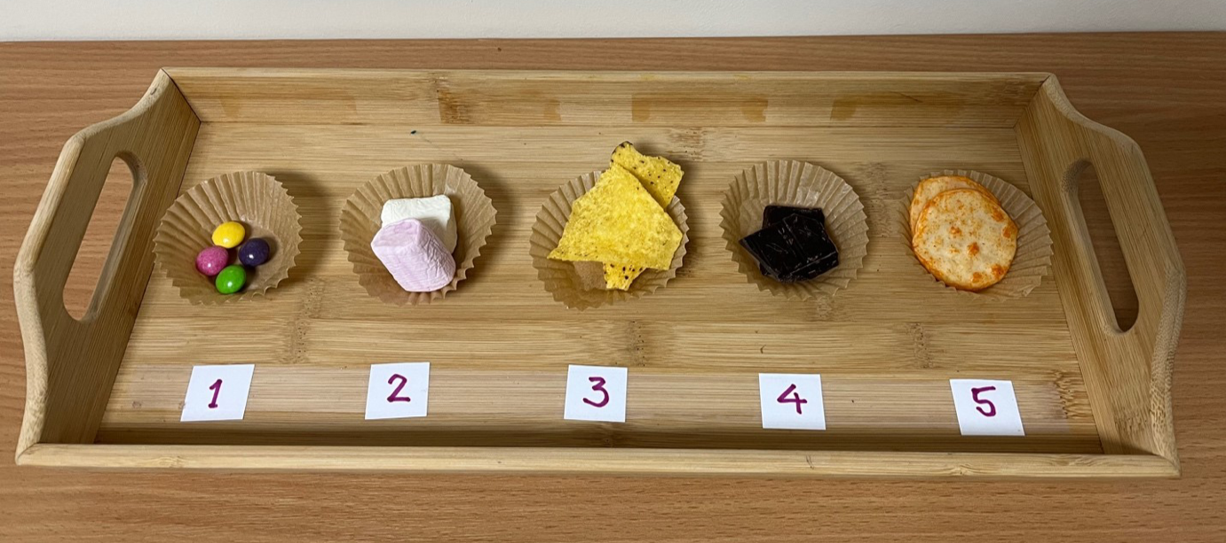
Figure 1 snacks presented to participants
The Mindfulness Attention Awareness Scale (MAAS) (Brown & Ryan, 2003) is a 15-item questionnaire regarding how frequently or infrequently a participant has a day-to-day experience (see appendix 3). Ratings are on a 1-6 Likert scale where 1 is coded as ‘almost always’, 2 as ‘very frequently’, 3 as ‘somewhat frequently’, 4 as ‘somewhat infrequently’, 5 as ‘very infrequently’, and 6 as ‘almost never’. A high score indicated a high level of dispositional mindfulness. This scale has been validated in its ability to measure mindfulness (MacKillop & Anderson, 2007).
Design
This study was experimental and used a repeated measures design that was counterbalanced. Participants were required to visit the lab twice and give ratings of 5 different foods. The two conditions were positively induced mood and negatively induced mood, which is completed through an autobiographical memory task. This means that every participant had to take part in all (two) conditions, but the odd numbered participants did the positive condition first and the even numbered participants negative first. The study looked into the effect of induced mood and the relationship of mindfulness with taste perception.
Procedure
Psychology and sport-science students signed up via SONA to take part. All researchers visited the lab multiple times, prior to testing participants, to familiarize themselves with the environment and procedure. The participant turned up to the Lloyd building at their chosen time slot and was asked to take a seat at the desk in the lab. On the desk they saw a laptop with a qualitrics form open, a tray with skittles, marshmallows, tortillas, dark chocolate, and rice crackers on, a jug of water, a cup of water, an empty cup, a napkin and a consent form (see Figure 2). All the food and equipment were presented with gloves prior to the participant’s arrival, to avoid any possible hygiene issues.

Figure 2 lab set out for experiment
Before any further actions took place, informed consent was obtained from the participant, which stated the measures that were going to be taken. They were asked to read the information sheet and sign the consent form (see appendix 4, 5 & 6). The consent sheets were kept safe with the supervisor in a locked cabinet. No deception was present, but the hypothesis remained unrevealed to reduce the risk of demand characteristics. No distress should have been caused by the procedure, and it was made clear that participants could leave any questions blank they were uncomfortable answering. The researcher also encouraged the participant to try all foods presented to them, otherwise their data was disregarded. Participants could rinse through their mouth with water or spit out food they disliked in the empty cup provided. The researcher left the room to allow the participant to begin and follow the survey instructions (see appendices 28 & 29).
Participants were asked their student number for confidentiality, and their age and gender for individual differences. They were then asked to indicate how hungry they were and how their mood had been over the past week on visual analogue scales. This is important as we wanted to be able to see our mood inducing method was the reason their mood either heightened or lowered. This was followed by a questionnaire based upon their everyday experiences, which measured their state of mindfulness or dispositional mindfulness. It was a brief version of the MAAS (Brown & Ryan, 2003) to prevent fatigue or boredom.
In the positive condition, the participants were asked to recall an event front the past month that elevated their mood, in as much detail as possible. They then provided at least five things or events that make them feel good. Participants should have then indicated how strongly they feel emotions, how much their mood varies, and how easily they are swayed by their moods and feelings. This was followed by a visual analogue scale where they revealed their current mood. The negative condition was set out the exact same, except participants were asked to recall events that negatively impacted their mood, rather than lifted their mood.
The final stage of the study was where the participant tasted the five plant-based foods. They were requested to indicate which tastes they could detect in the food (sweet, salty, sour, bitter, and spicy); how much they enjoyed specific attributes of the food (smell, texture, and appearance); whether they liked the food; and whether they would have eaten more of it. They repeated this cycle of questions for each of the individual food item until they were greeted with the page saying the experiment is complete. All this data was automatically stored by Qualitrics and imported into SPSS. Participant’s names were not stored with the data and the data was stored on a password protected computer in the lab.
The researcher returned to the room and asked them if they have any questions, provided them an interim debrief sheet, and reminded them to return for part 2 at the exact same time the following week (see appendix 7). The same researcher tested the participant for both their conditions. Once they completed the second condition, the participant was handed a debrief sheet of the experiment they took part in (see appendix 8 & 9). There were contacts on there if the participant had any questions regarding the results or felt any distress or harm which was a result of this study. The researcher thanked them for taking up their time to take part in their study and rewarded them with two SONA credits per visit, so four in total.
Once the participant left, the researcher took a picture of their left-over food (if any) which provided them additional information regarding food consumption for their research. The photos were coded and paired up with the SPSS data by the supervisor, who shared that with the team. The area was then thoroughly cleaned and prepped for the next participant.
Data analysis
The types of analyses used for the data collected were pair sample t-tests and/or Wilcoxon-test, if t-tests were not appropriate, and Pearson’s and/or Spearman’s correlations.
Results
Before running any tests, skewness and kurtosis were tested to assess for normality as the sample size of the study is small. Baseline hunger, baseline mood, and moods post-induction in both conditions had skewness and kurtosis statistics less than two, thus are normally distributed (see appendix 10). Most taste ratings were normally distributed, except skewness of dark chocolate sweet ratings in the positive condition was 2.079. Additionally, skewness of rice crackers sweet ratings in the negative condition was 2.344, thus non-parametric tests will need to be ran on this data instead (see appendix 11). The MAAS scores were normally distributed (see appendix 12). The data regarding consumption of the snacks was normally distributed (see appendix 13).
Paired samples t-tests were run to determine change was due to this studies manipulation (see appendices 14 & 15). There was no significant difference in baseline hunger between the positive condition (M = 47.50, SD = 25.91) and negative condition (M = 45.03, SD = 28.77) (t₃₁ = 0.62, p = 0.54). There was no significant difference in baseline mood between the positive condition (M = 47.50, SD = 18.94) and negative condition (M = 52.56, SD = 20.58) (t₃₅ = -1.19, p = 0.24). This means that baseline hunger and mood were controlled across conditions. There was a significant difference in the positive condition between baseline mood and mood post-induction (M = 62.89, SD = 16.75) (t₃₅ = -6.21, p < 0.001). There was no significant difference in the negative condition between baseline mood and mood post-induction (M = 52.75, SD = 17.75) (t₃₅ = -0.59, p = 0.95). This indicates that the procedure worked for inducing a positive mood, but not a negative mood. There was a significant difference in mood post-induction between the positive and negative condition (t₃₅ = 2.17, p = 0.04), which demonstrates taste perception was measured against two different moods.
Sweetness was detected in skittles, marshmallows, dark chocolate, and rice crackers; sourness in skittles; saltiness in tortillas and rice crackers; bitterness in dark chocolate; and spiciness in rice crackers. Paired samples t-tests were run, and Wilcoxon signed rank tests (non-parametric t-test equivalent) where appropriate, for these taste ratings in each condition and there were no significant differences found (see table 1 and appendices 16, 17, 18 & 19). This means the null hypothesis should be accepted as mood has not been found to affect taste ratings.
Table 1 means, standard deviations, t-, z-, and p-values of mood’s influence on taste ratings
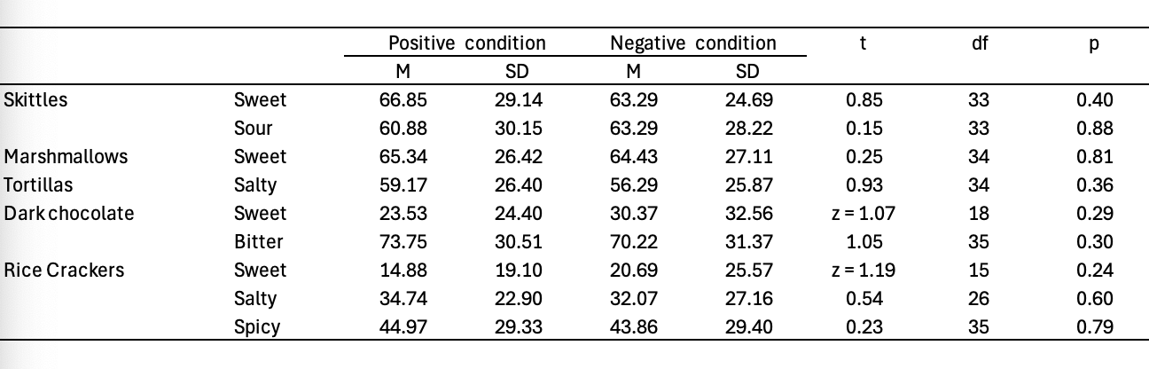
Pearson’s correlations, and Spearman’s (non-parametric correlation) where appropriate, were run for MAAS scores with the tastes detected in each snack for both conditions. There was a significant positive correlation between MAAS score and the sweetness of skittles in the positive condition (r = -0.39, p = 0.02) (see appendix 20). There were no other significant relationships found (see table 2 and appendices 21, 22 & 23). Therefore, the null hypothesis should be accepted as not all taste ratings have a positive relationship with mindfulness.
Table 2 Perason’s/Spearman’s r and p-values of the relationship between mindfulness and taste ratings
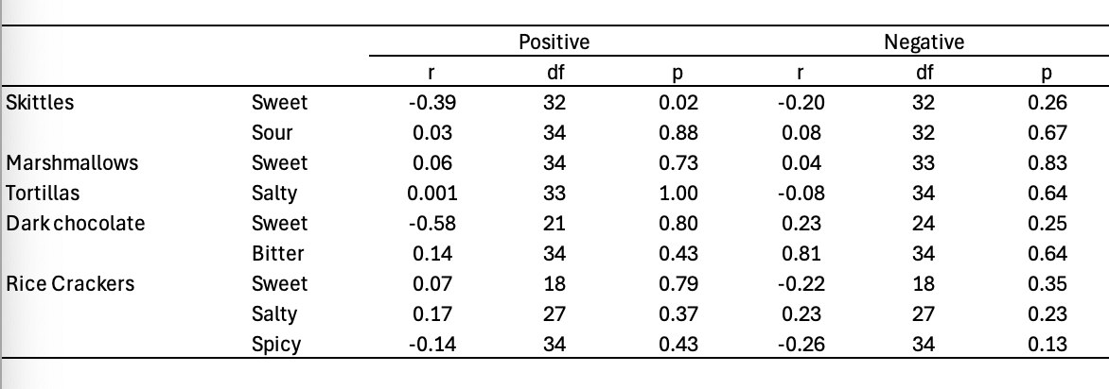
As an addition to this studies aims, paired samples t-tests were run to see if participant’s mood affected their consumption of the snacks (see appendices 24 & 25). There were no significant findings (see table 3).
Table 3 means, standard deviations, t-, and p-values of mood’s influence on snack consumption
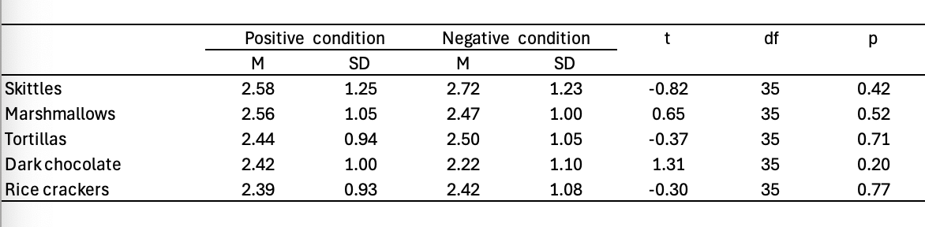
Moreover, Pearson’s correlations were run between MASS scores and snack consumption for both conditions (see appendices 26 & 27). There was a significant positive correlation between mindfulness and the consumption of rice crackers in the positive (r₃₄ = 0.37, p = 0.03) and negative condition (r₃₄ = 0.41, p = 0.01). Mindfulness also had a significant positive correlation with the consumption of tortillas in the negative condition (r₃₄ = 0.38, p = 0.02). There were no other significant relationships found (see table 4).
Table 4 Perason’s r and p-values of the relationship between mindfulness and snack consumption
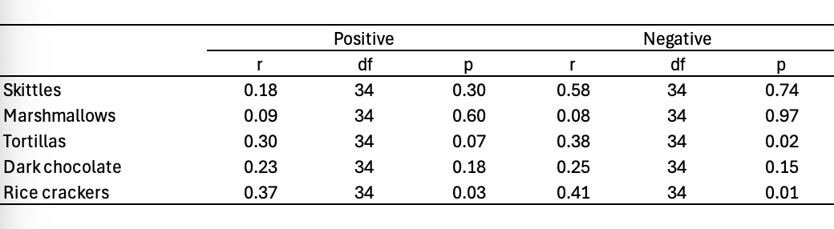
Discussion
Participants’ mean hunger levels remained the same at the start of both conditions. This means any changes in their consumption of snacks was not due to how hungry they were. The study’s method in manipulating a positive mood in participants was successful, unlike the method to induce a negative mood. However, due to the mood induction being successful in one condition, the mean mood in the positive condition was significantly higher than the mean mood in the negative condition, thus, any significant taste rating findings could be explained by mood.
Despite the success in manipulating the participants’ moods, this became insignificant as a result of them not reporting significantly different taste ratings in their different moods. This would imply there is no cause-and-effect relationship between mood and taste ratings, which contradicts Wang and Spence’s (2017) and Noel and Dando’s (2015) findings on heightened sweet taste in a positive mood. These unexpected findings can be supported by Chan et al (2024) inability to find a difference in sour or bitter taste when induced to feel a negative emotion and, a study that investigated the directionality of taste-emotion metaphoric association (Zhou & Tse, 2021). They found that sweet food could increase positive emotion and decrease negative emotion, in contrast, bitter food could reduce positive emotion and enhance negative emotion. However, when participants’ emotions were induced, their taste ratings of food were not affected. This infers that the association between taste and emotion is unidirectional as taste can influence emotion but, emotion has not been found to influence taste.
There was only one significant correlation between mindfulness and taste ratings, which was trait mindfulness scores were found to have a positive relationship with the skittles sweetness rating, when participants were in a positive mood. This infers that when an individual is in a positive mood and is highly mindful, they are more likely to rate certain foods as sweeter, than an individual who is in a lower mood and highly mindful, or in a positive mood and is low in dispositional mindfulness. It was mentioned previously that Heeter (1992) stated that an individual’s senses are heightened when they pay more attention and have a compelling awareness throughout the day, but this does not provide an explanation as to why this relationship between mindfulness and sense of taste was found solely in the positive mood condition. The association between emotional reactivity, how inclined an individual is to feel and express intense emotions frequently (Karrass et al, 2006), and dispositional mindfulness was explored (Himes et al, 2020). Their findings demonstrated that individuals presented less negative emotional reactivity in response to a stressor when they acted with higher levels of awareness and non-judgement. This suggests that those who practice dispositional mindfulness daily decrease their negative emotions, thus, increase reactions in positive emotions. This negative correlation between trait mindfulness and negative emotional reactivity may illustrate why there was only a positive correlation between skittles sweet taste and mindfulness levels when participants were induced to feel positive, signifying that mindfulness and positive emotion act together to strengthen sweet taste.
It was decided to run for the effects of mood on the consumption of food as an addition to the original aims of the study as nothing significant was found on the taste ratings of food. Participants did not eat significantly different amounts of any of the snacks when in different moods. Evers et al (2013) research into food intake being triggered by emotions can support these findings as they found in their second study that positive and negative emotions produced the same extent of calorie intake. This implies that an individual is likely to consume the same amount of food whether they are in a positive or negative mood.
According to Hsu and Forestell (2021) and other previous research, mindful tasks have been successful in reducing snack intake, particularly salty snacks (Forman et al, 2016). It should be expected to find a negative correlation between an individual’s state of mindfulness and the number of snacks they consume. Despite this, there were three significant positive correlations found between mindfulness scores and the consumption of food, which happened to be the snacks participants detected saltiness in. It was found that the participants who ate more rice crackers, in both conditions, were more mindful in everyday life than others. Similarly, participants who ate more tortillas, only in the negative condition, were more mindful in everyday life than others. This would suggest an individual who is high in dispositional mindfulness is more likely to consume more salty foods than someone who is low in dispositional mindfulness, and than any other foods that are not salty. The non-significant correlations infer that an individual’s state of mindfulness does not have an impact on the likelihood of them eating most types of foods, which can be advocated by Hong et al (2012).
Implications
As briefly mentioned previously, the findings of this study contradict Wang and Spences (2017) findings of sweet taste being stronger when an individual is in a positive mood, compared to a negative mood. There were no significant findings of the sort in this study, challenging conclusions made regarding taste evaluation following mood induction. It may not be applicable to all types of populations. Moreover, this study also counteracts Chan et al (2024) findings that being induced into a positive mood increases sweet taste. This questions whether their methodology of not tasting food is applicable to what an individual may actually taste as this research argues people do not experience different strengths of any tastes in different moods. However, these findings do reinforce theirs concerning negative mood induction not having an effect on taste perception. This study’s insignificant findings additionally contradict the association between positive emotion and high sweet taste, and negative emotion and high sour and bitter tastes reported by Noel and Dando (2015). This has taught us that although manipulated mood may not influence taste perception, as stated in this research, there is a relationship between the two, meaning we cannot determine the cause or effect of their association as of yet. Thus, mood may not play as big of a role in the taste of food as first believed.
Previous research, such as Hong et al (2012), were not able to discover any significant relationships between mindfulness and taste perception, despite someone who is high in dispositional mindfulness being more aware of surroundings, textures, flavours, etc. This study filled a small gap in this area of research by unveiling that the more mindful an individual is the more sweet taste they detect in a food, when in a positive mood. Although, the relationship between mindfulness and sour, salty, bitter, and sour taste still remains unknown. This infers that daily mindful tasks may be beneficial for making food taste sweeter, thus potentially more enjoyable, as low-sweet foods have been found to be less enjoyable (Van Vuuren et al, 2016).
Arch et al (2016) determined that mindfulness instructions can lead to a reduction in calories consumed of unhealthy foods, which can be challenged by the findings in this research indicating that the higher state of trait mindfulness, the higher the consumption of salty foods, generally known as unhealthy food. This would incline one to believe that daily mindful tasks do not inspire healthy eating, in fact, they could hinder a healthy diet, but the reason for this is unexplored. Therefore, mindfulness tasks should not be recommended to aide healthy eating, but potentially to eat more. Despite, Hsu and Forestell (2021) stating that the overconsumption of food can be restricted by a mindful task. If an individual who does not usually like salty foods, being more mindful may open them up to try them again, but it may not be the most efficient method for encouraging other types of foods.
Strengths
The study is counterbalanced as participants are taking part in both conditions, which means half the participants complete the positive condition first, then the negative, and the other half complete the negative condition first. This ensures the results are not biased by the order of which conditions occur.
The study is inclusive towards vegans or fussy eaters by presenting foods that are plant-based and familiar. This allows a variety of different students to take part.
In this study, the two conditions take place on separate days, which prevents the likelihood of demand characteristic occurring, such as, participants guessing the aim of the study, or them getting bored or tired.
This study takes into consideration all types of tastes in each individual food. This is beneficial as the difference between the dominant taste of a food and the less dominant tastes can be examined easily.
Procedural checks are carried out in this study. This is important for assessing the quality of the study’s manipulation techniques and indicating whether the participants turned up to the second condition in the same state of mood and hunger as the first condition in the week previous.
Limitations
This study lacks population validity as it has a small sample size. This suggests that there are not enough participants to represent their specific population at university, indicating that this study should be replicated, but with significantly more students to see if significant results can be found. However, the diversity of the sample is low due to it only being conducted on students at Bangor University. This may be the reason as to why the results of this study differ to the majority of previous studies based on the effect of manipulated mood on taste perception, highlighting that these results likely cannot be applicable to infants, children, older adults, or people their age who have not attended university.
There is a high likelihood of social desirability bias being present in this study. First, participants may not have answered truthfully to how they were feeling on the scale for mood post-induction. This study may not have appeared successful in negatively manipulating an individual’s mood as the students may have felt inclined to hide any negative emotion, so they were not viewed as pessimistic themselves. People have been motivated to supress how much negative emotion they were genuinely feeling (Gehring Reimer, 2008). This could be prevented by emphasising to the participants the anonymity of their data and indicating that the study is a safe environment to open up, without being judged. Second, participants may have just rushed through the survey as the results of this research do not affect them, and they may just have wanted to gain their SONA credits and be out of the room as soon as possible. This implies that questions and ratings of food may have been answered inaccurately and thoughtlessly, thus, potentially leading to the insignificant findings.
This study assumes longevity of manipulated emotion. Participants rate their emotion immediately after manipulation and do not rate it again for the rest of the study. There is no way of knowing if the participants stayed in their significant positive mood throughout the whole process of carefully rating each snack, their mood could have neutralized the further they went through the study. This could explain the unexpected insignificant findings as there may not be a difference between moods by the end of the survey. A method to check for this is by adding mood rating scales in-between rating foods, and if their mood has changed, perhaps ask participants to recall their memories again.
The method for negatively manipulating the participants’ moods was unsuccessful. this implies that different methods of mood inductions should be considered instead of just memory recall. For example, use of visual or auditory stimuli, such as, videos, pictures, or music could be more effective in inducing a negative mood.
The study may be slightly deficient in task validity. It is possible that participants had different interpretations of how strong their positive or negative mood was, which emphasises that the scales may not be an accurate measure of mood. There should be more labels on the scales to give a clearer representation of how the participants may be feeling. Further, it is difficult to measure the effect of mood manipulation, and the relationship of mindfulness, on food consumption with a few snacks. If participants were given a full meal, it may have provided similar results to previous studies. The study also does not consider if any participants are on medication. This is a problem as some medications can affect taste, so participants should be asked, before taking part, if they are on any medication. This would eliminate the measurement of taste perception being interfered with.
There is a chance of situational variables being present. For example, there may have been noises outside the room, disrupting the participant’s concentration, or the temperature of the room could have been different for the two conditions, which may have been off-putting.
There is a lack of findings to support the significant findings of the positive relationship between trait mindfulness and consumption of salty foods. This alludes that these results could be a fluke, and the study should be replicated to determine the reliability and validity of the findings.
Conclusion
Students do not experience different tastes of foods or consume different amounts of snacks when in different moods. Although, students, in a positive mood, who are high in trait mindfulness are more likely to indicate foods tasting sweeter than those who are not mindful and in a negative mood. Additionally, highly mindful students are likely to consume more salty snacks than students low in dispositional mindfulness.

References
Akal, U., Delilbasi, C., Yilmaz, T., Redzep, E., & Setkaya, D. (2003). Evaluation of Some Factors Affecting Taste Perception. Research Gate. https://www.researchgate.net/profile/Cagri-Delilbasi/publication/299757669_Evaluation_of_some_factors_affecting_taste_perception/links/5705013e08ae74a08e270ce8/Evaluation-of-some-factors-affecting-taste-perception.pdf
American Psychological Association. (2022). Mindfulness. American Psychological Association. https://www.apa.org/topics/mindfulness
Arch, J. J., Brown, K. W., Goodman, R. J., Della Porta, M. D., Kiken, L. G., & Tillman, S. (2016). Enjoying Food Without Caloric Cost: The Impact of Brief Mindfulness on Laboratory Eating Outcomes. Behaviour Research and Therapy, 79, 23–34. https://doi.org/10.1016/j.brat.2016.02.002
Chan, K. Q., Tong, E., Tan, D., & Koh, A. (2024). APA PsycNet. Apa.org. https://psycnet.apa.org/fulltext/2013-32692-001.html
Evers, C., Adriaanse, M., de Ridder, D. T. D., & de Witt Huberts, J. C. (2013). Good Mood Food. Positive Emotion as a Neglected Trigger for Food Intake. Appetite, 68, 1–7. https://doi.org/10.1016/j.appet.2013.04.007
Forman, E. M., Shaw, J. A., Goldstein, S. P., Butryn, M. L., Martin, L. M., Meiran, N., Crosby, R. D., & Manasse, S. M. (2016). Mindful Decision Making and Inhibitory Control Training as Complementary Means to Decrease Snack Consumption. Appetite, 103, 176–183. https://doi.org/10.1016/j.appet.2016.04.014
Gehring Reimer, S. (2008, September 26). The Hidden Cost of Hiding Feelings: Emotion Suppression and Inauthenticity in Social Anxiety. University of Waterloo. https://uwspace.uwaterloo.ca/items/43f28db7-b613-4ce9-8563-54bba88d931f
Gravina, S. A., Yep, G. L., & Khan, M. (2013). Human Biology of Taste. Annals of Saudi Medicine, 33(3), 217–222. https://doi.org/10.5144/0256-4947.2013.217
Guido, D., Perna, S., Carrai, M., Barale, R., Grassi, M., & Rondanelli, M. (2016). Multidimensional Evaluation of Endogenous and Health Factors Affecting Food Preferences, Taste and Smell Perception. The Journal of Nutrition, Health & Aging, 20(10), 971–981. https://doi.org/10.1007/s12603-016-0703-4
Heeter, C. (1992). Being There: The Subjective Experience of Presense. MIT Press. https://d1wqtxts1xzle7.cloudfront.net/38804558/Being_There__The_Subjective_Experience_of_Presence-libre.pdf?1442599773=&response-content-disposition=inline%3B+filename%3DBeing_there_The_subjective_experience_of.pdf&Expires=1739291350&Signature=Os3ayPJHP84LPTsGid7mla5gRftS8SByXtRjffAXOYFHZf-Syk36KuCYGQxUIUM2MhdUuls5EFZP77b7lTYPZ04tQHne3OyGjajbwMCgan5SF1PPDXkYbxz1fAB3M0xhewQji1P0~0ok84inDrFUDqQGKXjKfZjAjFzLYgBI-3j5ujq-CdT33Xm4xcyJhLrimqUUbLRYicX9TW9ZsGK5m0etNC9R-UvhGrRfBQSqoCRwU0MbN3BjBpOPgojY8gUcfRbYqYdf3oBjhkLAh5IPKEmrh-o8aQJwE5Z2b6RRkb4Qfo-c~1HUQ5fR~hEp6LHXfMJANMhKKcGVQ79ozMRy2A__&Key-Pair-Id=APKAJLOHF5GGSLRBV4ZA
Himes, L., Hubbard, N. A., Maruthy, G. B., Gallagher, J., Turner, M. P., & Rypma, B. (2020). The Relationship between Trait Mindfulness and Emotional Reactivity Following Mood Manipulation. Mindfulness, 12(1), 170–185. https://doi.org/10.1007/s12671-020-01510-7
Hong, P. Y., Lishner, D. A., & Han, K. H. (2012). Mindfulness and Eating: An Experiment Examining the Effect of Mindful Raisin Eating on the Enjoyment of Sampled Food. Mindfulness, 5(1), 80–87. https://doi.org/10.1007/s12671-012-0154-x
Hopwood, T., & Schutte, N. (2017). Dispositional Mindfulness - an overview. Science direct. https://www.sciencedirect.com/topics/psychology/dispositional-mindfulness
Hsu, T., & Forestell, C. A. (2021). Mindfulness, mood, and food: The mediating role of positive affect. Appetite, 158, 105001. https://doi.org/10.1016/j.appet.2020.105001
Karrass, J., Walden, T. A., Conture, E. G., Graham, C. G., Arnold, H. S., Hartfield, K. N., & Schwenk, K. A. (2006). Relation of Emotional Reactivity and Regulation to Childhood Stuttering. Journal of Communication Disorders, 39(6), 402–423. https://doi.org/10.1016/j.jcomdis.2005.12.004
MacKillop, J., & Anderson, E. J. (2007). Further Psychometric Validation of the Mindful Attention Awareness Scale (MAAS). J Psychopathol Behav Assess, 29. https://doi.org/10.1007/s10862-007-9045-1
McLaughlin, S., & Margolskee, R. F. (1994). The Sense of Taste. American Scientist, 82(6), 538–545. JSTOR. https://doi.org/10.2307/29775325
Nakagawa, M., Mizuma, K., & Inui, T. (1996). Changes in Taste Perception Following Mental or Physical Stress. Chemical Senses, 21(2), 195–200. https://doi.org/10.1093/chemse/21.2.195
Nicolau, J. L., Mellinas, J. P., & Martín-Fuentes, E. (2020). The halo effect: A longitudinal approach. Annals of Tourism Research, 83(1), 102938. https://doi.org/10.1016/j.annals.2020.102938
Nikrad, H. (2019). The Effect of a Brief Mindfulness Induction on Perceptions of Taste and Caloric Consumption in Emotional Eating in a Laboratory Context. CU Scholar. https://scholar.colorado.edu/concern/undergraduate_honors_theses/t722h928x
Noel, C., & Dando, R. (2015). The Effect of Emotional State on Taste Perception. Appetite, 95, 89–95. https://doi.org/10.1016/j.appet.2015.06.003
Payne, R., & Cooper, C. (2001). Emotions at Work. Google Books. https://books.google.co.uk/books?hl=en&lr=&id=a0azIPHoj6QC&oi=fnd&pg=PA21&dq=define+mood&ots=HDIDAUq1BC&sig=eNyOFnfI1zkK-HfWpPABWBmwxks&redir_esc=y#v=onepage&q=define%20mood&f=false
Platte, P., Herbert, C., Pauli, P., & Breslin, P. A. S. (2013). Oral Perceptions of Fat and Taste Stimuli Are Modulated by Affect and Mood Induction. PLoS ONE, 8(6), e65006. https://doi.org/10.1371/journal.pone.0065006
SKUDE, G. (2009). Some Factors Influencing Taste Perception for Phenylthiourea (P.T.C.). Hereditas, 50(2-3), 203–210. https://doi.org/10.1111/j.1601-5223.1963.tb01906.x
Taylor, C. M., Wernimont, S. M., Northstone, K., & Emmett, P. M. (2015). Picky/fussy Eating in children: Review of definitions, assessment, Prevalence and Dietary Intakes. Appetite, 95, 349–359. https://doi.org/10.1016/j.appet.2015.07.026
Tokat, P., & Yilmaz, I. (2023). Neurogastronomy: Factors Affecting the Taste Perception of Food. International Journal of Gastronomy Research, 2(1), 1–10. https://doi.org/10.56479/ayed.2022.10261
Van Vuuren, M. A. J., Strodl, E., White, K. M., & Lockie, P. D. (2016). Taste, Enjoyment, and Desire of Flavors Change After Sleeve Gastrectomy-Short Term Results. Obesity Surgery, 27(6), 1466–1473. https://doi.org/10.1007/s11695-016-2497-1
Wang, Q. (Janice), & Spence, C. (2017). “A Sweet Smile”: The Modulatory Role of Emotion in How Extrinsic Factors Influence Taste Evaluation. Cognition and Emotion, 32(5), 1052–1061. https://doi.org/10.1080/02699931.2017.1386623
Zhou, Y., & Tse, C.-S. (2021). Sweet Taste Brings Happiness, But Happiness Does Not Taste Sweet: The Unidirectionality of Taste-Emotion Metaphoric Association. Journal of Cognitive Psychology, 34(3), 1–23. https://doi.org/10.1080/20445911.2021.2020797

